**BizSol Classified web application**

**Technologies/Libraries:**

1. Asp.net mvc 5
2. C#
3. Identity framework v2.2.2
4. Entity framework v4.6.2
5. Code first approach
6. Sql server 2019
7. Visual studio 2019

**Identity framework:**

* This framework allows us to add features where users can register and log in with a local password.
* The framework also supports two-factor authentication, third-party identity providers and other features
* **Sign in Manager**
* This is one of the two pieces of the Identity framework
* As the name implies, the **Sign in Manager** can sign in a user once we validate the password.
* We can also use this manager to sign a user out.
* With forms authentication, the sign in and the sign out are done by managing a cookie.
* When we tell the Sign In Manager to sign a user in, the manager issues a cookie to the user's browser, and the browser will send this cookie on every subsequent request. It helps us identify that user.
* **Identity Middleware**
* This is the second piece of the framework −
* Reading the cookie sent by the Sign in Manager and identifying the user, this happens in the final piece of the framework, the Identity Middlewar.

**Identity OWIN:**

ASP.NET MVC and ASP.NET Core supports the Open Web Interface for .NET (OWIN). OWIN is an interface between .NET web applications and web server. The main goal of the OWIN interface is to decouple the server and the applications. It acts as middleware.

ASP.NET MVC, ASP.NET applications using middleware can interoperate with OWIN-based applications, servers, and middleware. It helps develop different types of authentication methods.

OWIN helps Facebook, Google, and Microsoft Accounts, and Twitter authentications. It acts as a middleware for those authentication programs. The following diagram shows the assembly for Facebook, Google, Microsoft Accounts, and Twitter.

**MVC:**

MVC is a design pattern used to decouple user-interface (view), data (model), and application logic (controller). This pattern helps to achieve separation of concerns.

Using the MVC pattern for websites, requests are routed to a Controller that is responsible for working with the Model to perform actions and/or retrieve data. The Controller chooses the View to display, and provides it with the Model. The View renders the final page, based on the data in the Model.

**Asp.net:**

ASP.NET extends the .NET platform with tools and libraries specifically for building web apps. These are some things that ASP.NET adds to the .NET platform:

* Base framework for processing web requests in C# or F#
* Web-page templating syntax, known as Razor, for building dynamic web pages using C#
* Libraries for common web patterns, such as Model View Controller (MVC)
* Authentication system that includes libraries, a database, and template pages for handling logins, including multi-factor authentication and external authentication with Google, Twitter, and more.
* Editor extensions to provide syntax highlighting, code completion, and other functionality specifically for developing web pages

**C#:**

C# is pronounced as "C-Sharp". It is an object-oriented programming language provided by Microsoft that runs on .Net Framework.

By the help of C# programming language, we can develop different types of secured and robust applications:

* Window applications
* Web applications
* Distributed applications
* Web service applications
* Database applications etc.

C# is approved as a standard by ECMA and ISO. C# is designed for CLI (Common Language Infrastructure). CLI is a specification that describes executable code and runtime environment.

C# programming language is influenced by C++, Java, Eiffel, Modula-3, Pascal etc. languages.

**Entity framework:**

Entity Framework is an open-source ORM framework for .NET applications supported by Microsoft. It enables developers to work with data using objects of domain specific classes without focusing on the underlying database tables and columns where this data is stored. With the Entity Framework, developers can work at a higher level of abstraction when they deal with data, and can create and maintain data-oriented applications with less code compared with traditional applications.

**Entity Framework Features:**

* Cross-platform: EF Core is a cross-platform framework which can run on Windows, Linux and Mac.
* Modelling: EF (Entity Framework) creates an EDM (Entity Data Model) based on POCO (Plain Old CLR Object) entities with get/set properties of different data types. It uses this model when querying or saving entity data to the underlying database.
* Querying: EF allows us to use LINQ queries (C#/VB.NET) to retrieve data from the underlying database. The database provider will translate this LINQ queries to the database-specific query language (e.g. SQL for a relational database). EF also allows us to execute raw SQL queries directly to the database.
* Change Tracking: EF keeps track of changes occurred to instances of your entities (Property values) which need to be submitted to the database.
* Saving: EF executes INSERT, UPDATE, and DELETE commands to the database based on the changes occurred to your entities when you call the SaveChanges() method. EF also provides the asynchronous SaveChangesAsync() method.
* Concurrency: EF uses Optimistic Concurrency by default to protect overwriting changes made by another user since data was fetched from the database.
* Transactions: EF performs automatic transaction management while querying or saving data. It also provides options to customize transaction management.
* Caching: EF includes first level of caching out of the box. So, repeated querying will return data from the cache instead of hitting the database.
* Built-in Conventions: EF follows conventions over the configuration programming pattern, and includes a set of default rules which automatically configure the EF model.
* Configurations: EF allows us to configure the EF model by using data annotation attributes or Fluent API to override default conventions.
* Migrations: EF provides a set of migration commands that can be executed on the NuGet Package Manager Console or the Command Line Interface to create or manage underlying database Schema.

**Application features**

**Home page:**

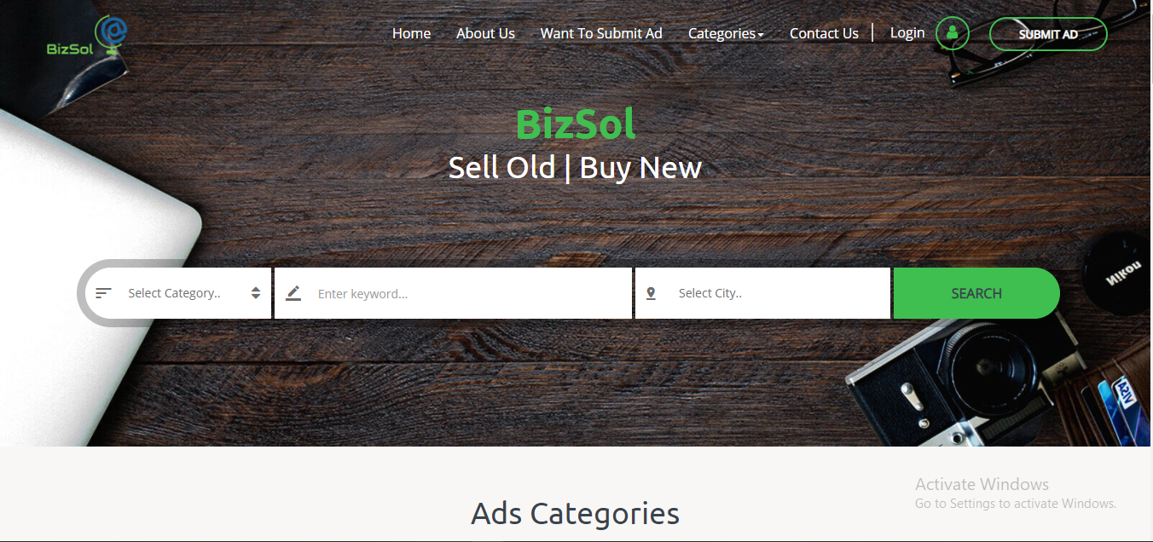

Home page contains different options in the nav bar there are several options like About us, Categories, Contact us, Login, Submit Ad also there is a search bar where user can search ads by City name, Category name and search text by clicking Search button user will navigate to the Ads section where he can find his searched ads also all ads available.

**Login:**

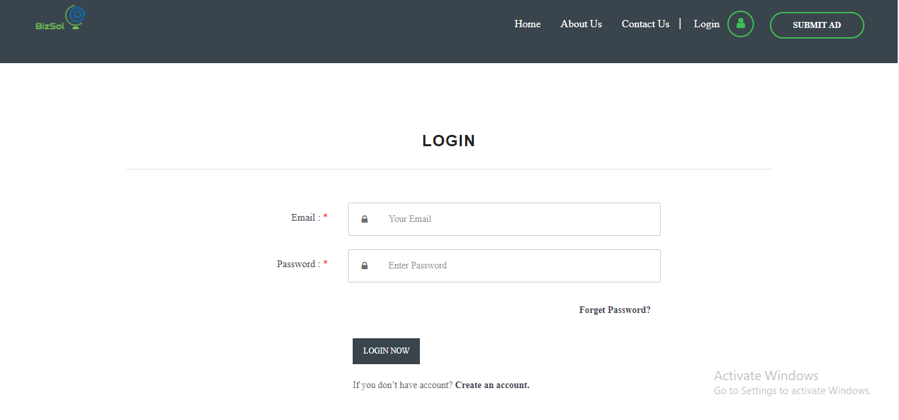

User can login into the application by enter its credentials like Email and Password.

**Ads Section:**

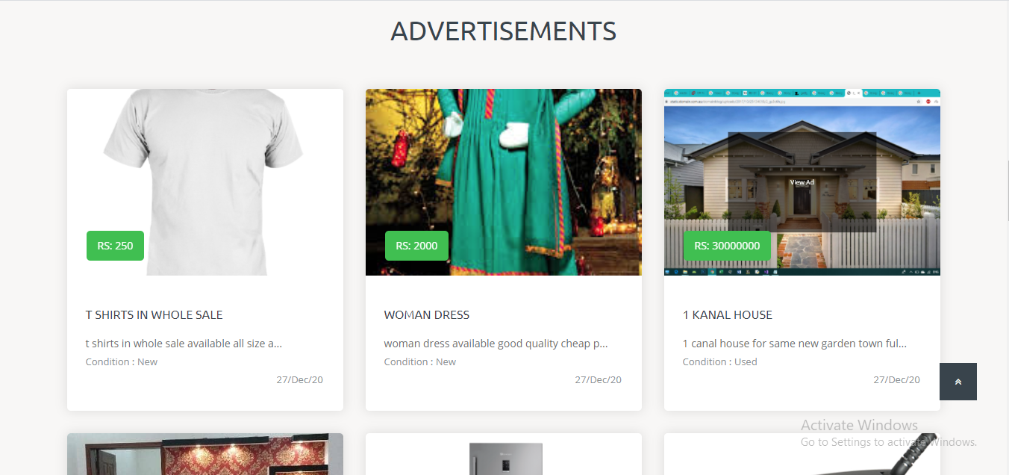

This section contains all the ads available also user can find its searched ads here

by clicking on ad he can view the ad details.

**Ad Detail:**

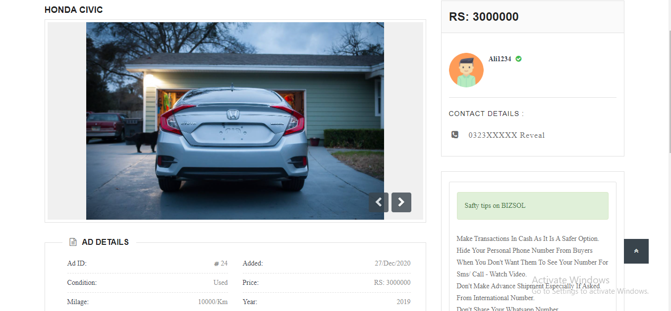

This page contains all the ad and user information who posted this ad like user name, contact details, ad title, description, price and other details as well

**Registration page:**

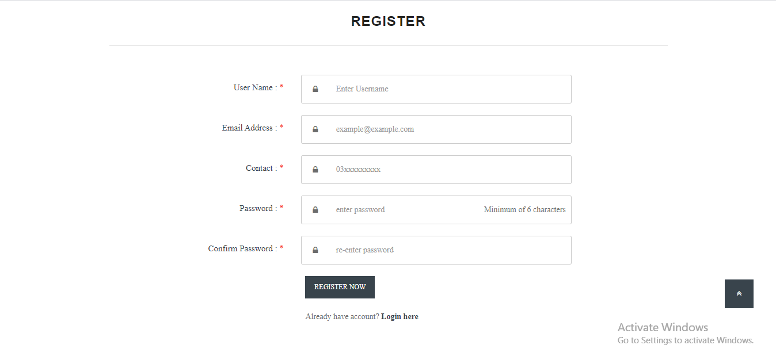

From this page user can register by putting necessary information to use other functionalities that is only visible to registered users.

**Categories:**



Registered user can post ad by selecting the category in which he wants to post its ads after that provide necessary information, he can submit the ad that will be visible to the all users.

**User profile:**

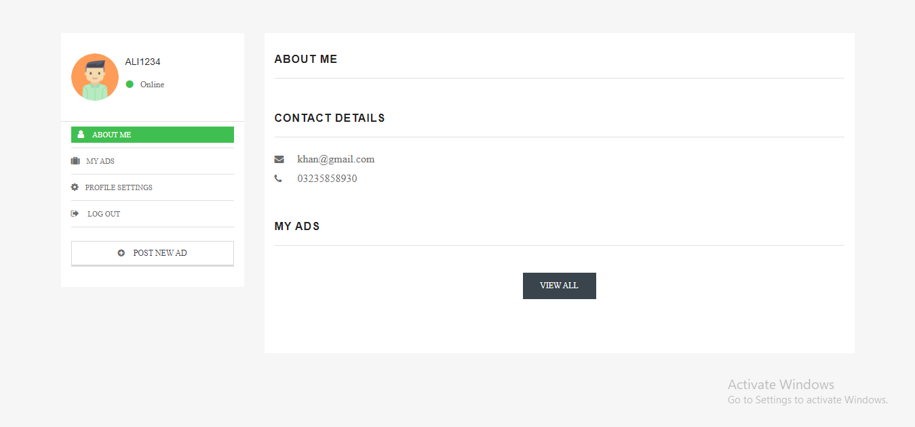

Here a user can see its profile information and change them also he can see all his posted ads, user can delete or edit his posted add from this section also user can logout from the application by clicking log out button.

**Profile settings:**

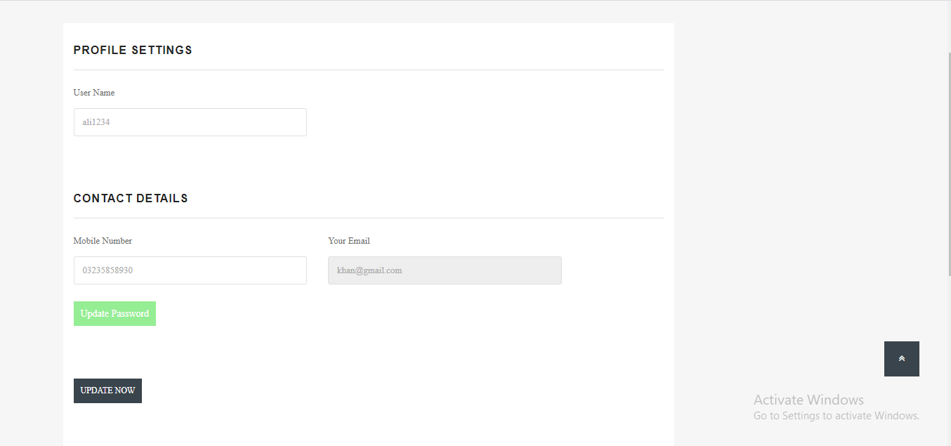

From here user can update his profile also user can change his password by clicking the update password button and follow given steps.

**Contact us:**

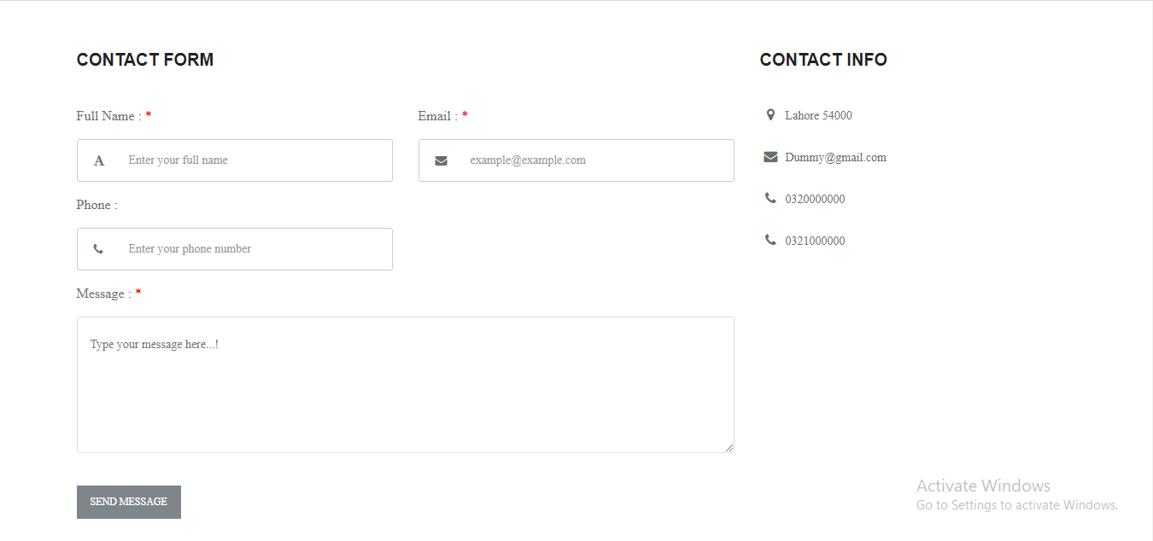

User can contact to the application owner/admin and tell about his issue or any other question he has by visiting this page and fill out necessary information by clicking send feed back button his query will be posted.